RESOLUTION NO.__________

RE: CERTIFICATE OF APPROPRIATENESS UNDER THE

PROVISIONS OF THE ACT OF THE PENNSYLVANIA

LEGISLATURE 1961, JUNE 13, P.L. 282 (53

SECTION 8004) AND BETHLEHEM ORDINANCE NO.

3952 AS AMENDED.

WHEREAS, it is proposed to replace door and add heat pump at 315 W 4thSt.

NOW, THEREFORE, BE IT RESOLVED by the Council of the City of Bethlehem that a Certificate of Appropriateness is hereby granted for the work.

Sponsored by: (s)

(s)

ADOPTED BY COUNCIL THIS DAY OF

(s)

President of Council

ATTEST:

(s)

City Clerk

HISTORIC CONSERVATION COMMISSION

CASE # 592– It is proposed to replace door and add heat pump at 315 W 4thSt.

OWNER/APPLICANT: Beth Starbuck & Steven Goldner

The Commission upon motion by Mr. Cornish seconded by Mr. Silvoy adopted the proposal that City Council issue a Certificate of Appropriateness for the proposed work described herein:

1. The proposal to replace door and add heat pump at 315 W 4thSt. was represented by Beth Starbuck.
2. The current 6 panel steel door with 2 upper lights will be replaced with a smooth fiberglass door with 6 upper lights and 2 vertical panels below.
3. The heat pump condensing unit will be located on the roof of the rear structure as shown in the photographic rendering.
4. The proposed motion was approved as submitted. Ms. Starbuck abstained due to a conflict of interest.

CU: cu

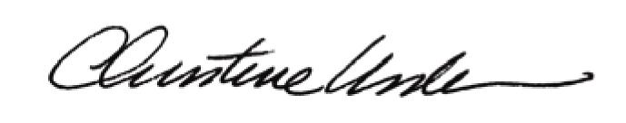

By:

Date of Meeting: June 20, 2016 Title: Historic Officer